Executive Leadership Team:
Our leadership team is driven to be a customer-focused, market-driven, profitable, financial services cooperative by providing innovative input financing services designed to empower rural communities and advance cooperative principles.

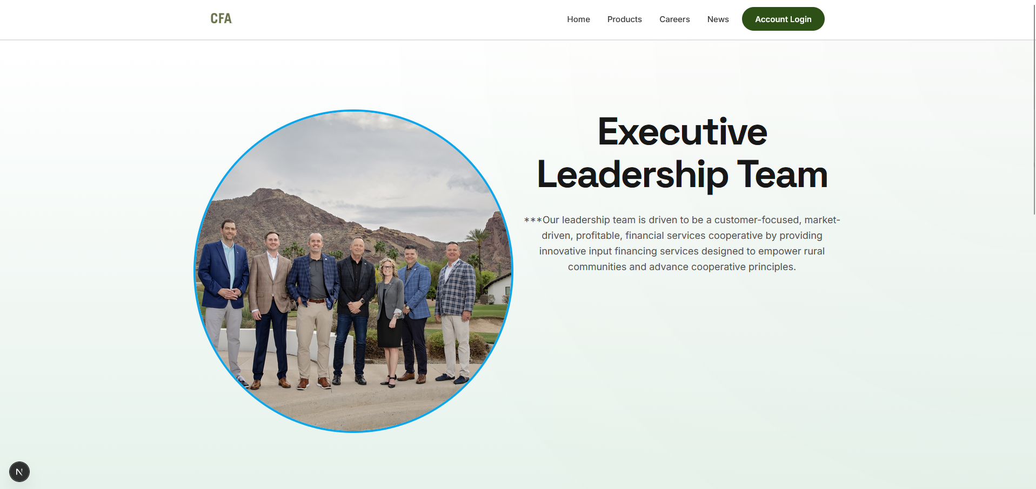
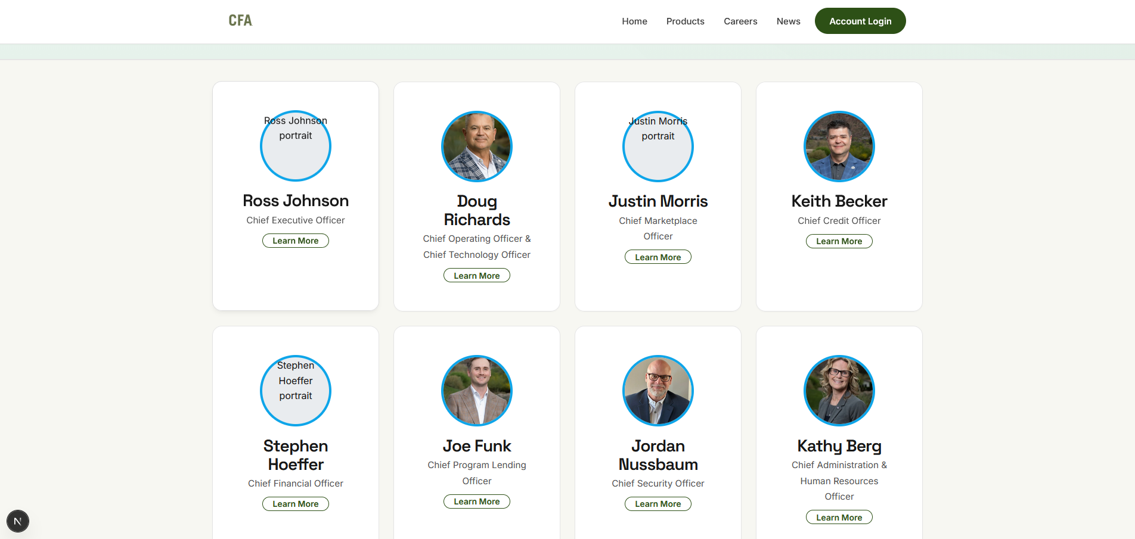

Board of Directors:
The board of directors is committed to provided insight and guidance to advance CFA's market position and provide value by representing our members.
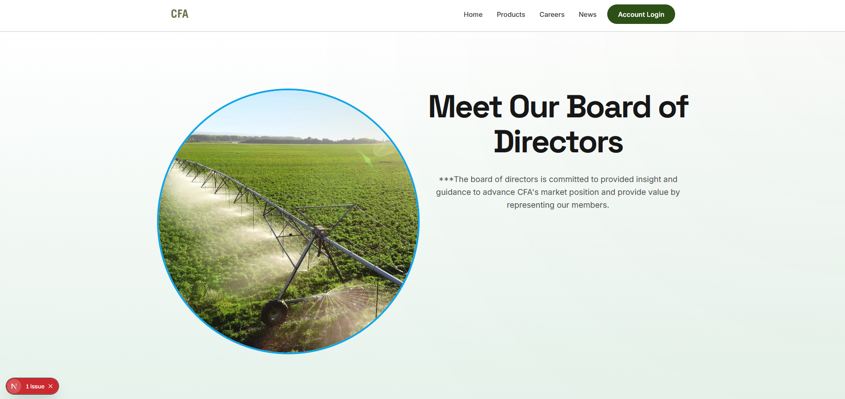
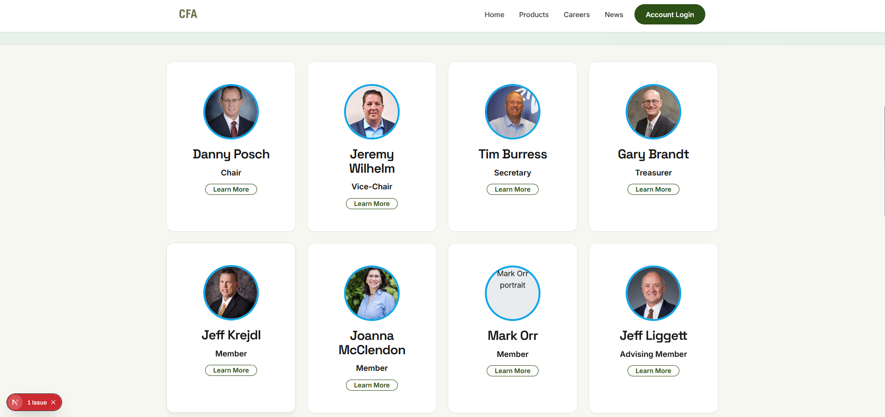

Membership:
The Cooperative Finance Association (CFA) is the nation's leading cooperatively owned provider of crop input finance products in the country. CFA has provided reliable financial products and services to the agricultural industry since 1943. Working exclusively with agricultural cooperatives for over 80 years gives us a superior understanding of the operational issues and financing requirements of your customers. Learn more about what CFA can provide your cooperative.
Exclusive Rates:
CFA provides the best possible market rates through our many strategic business partnerships. CFA stays on the cutting edge of the market using technical insights and market agility.
Trusted Guidance:
With over 80 years in the industry and 50 years partnering with CoBank, CFA can provide the stability and trust you are looking for in a lending partner. Our commmitment to financial success, security, and customer service is unmatched in the industry.
Community Support:
CFA delivers tailored financing options designed to empower rural communities and advance cooperative principles. Our cooperative exists to serve the needs of agricultural producers and the cooperatives that are the beneficial owners of CFA. We strive to make a positive impact within our member’s communities, strengthening rural America.
How Membership Works:
1.Get A Demo - Let one of our representatives show you what CFA can provide for your cooperative and members.
2. Apply Online - Eligibility is limited to agricultural cooperatives with a Class A Common Stock purchase of $2,000.
3. Enjoy Benefits - Enjoy access to CFA's wide range of financial products and services. A substantial portion of our earnings are also returned to our members as a patronage refund.
Membership Benefits:
Products and Services - Members have full access to CFA’s wide range of financial products and services, including commercial agribusiness loans and input finance loans. Additionally, our member cooperatives can offer dedicated financing options to their customers.
Patronage - CFA conducts the majority of its business on a patronage basis. A substantial portion of our annual earnings are returned to our members as a patronage refund. The patronage refund consists of both cash and Class B Common Stock.
Customer Service - We provide your team with loan lifecycle support and training. Despite utilizing an all-electronic delivery model, CFA recognizes and adapts to its unique and traditional membership by communicating with members however they prefer.
Technological Innovation - We put security and improving our product offerings as a top priority. By constantly reassessing our offerings and processes, we are able to reengineer our products and services to remain competitive in today's financial market. All of this is done with providing our members the highest quality offerings in a timely, convenient, and affordable manner.

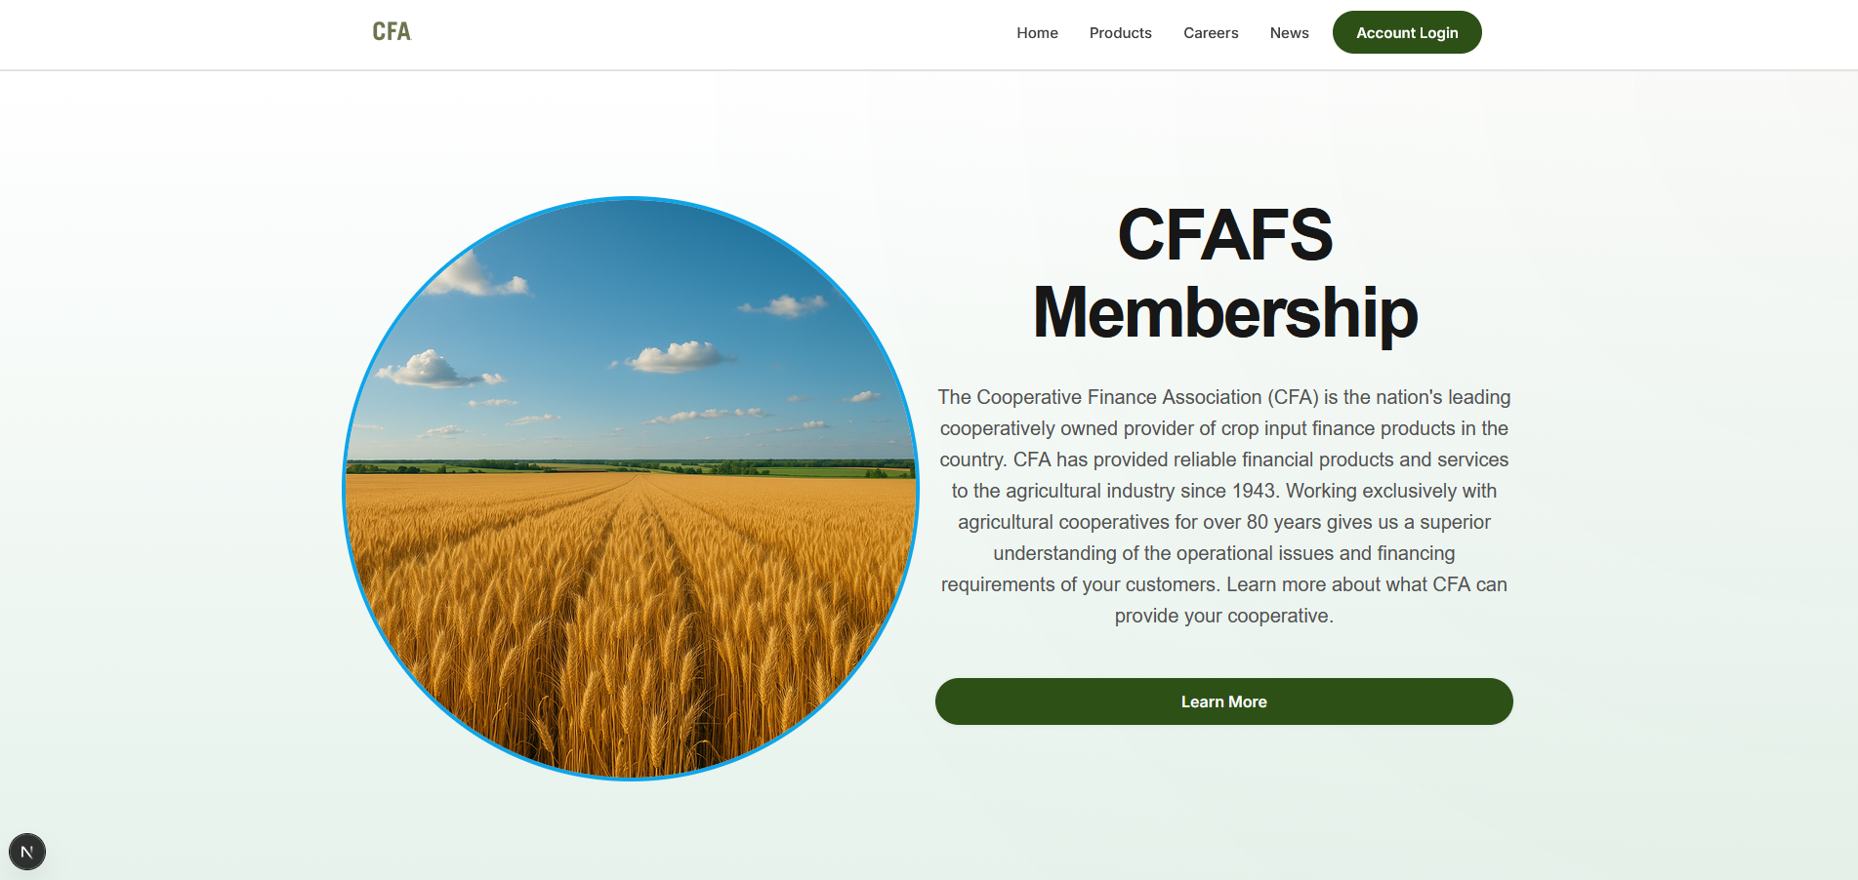
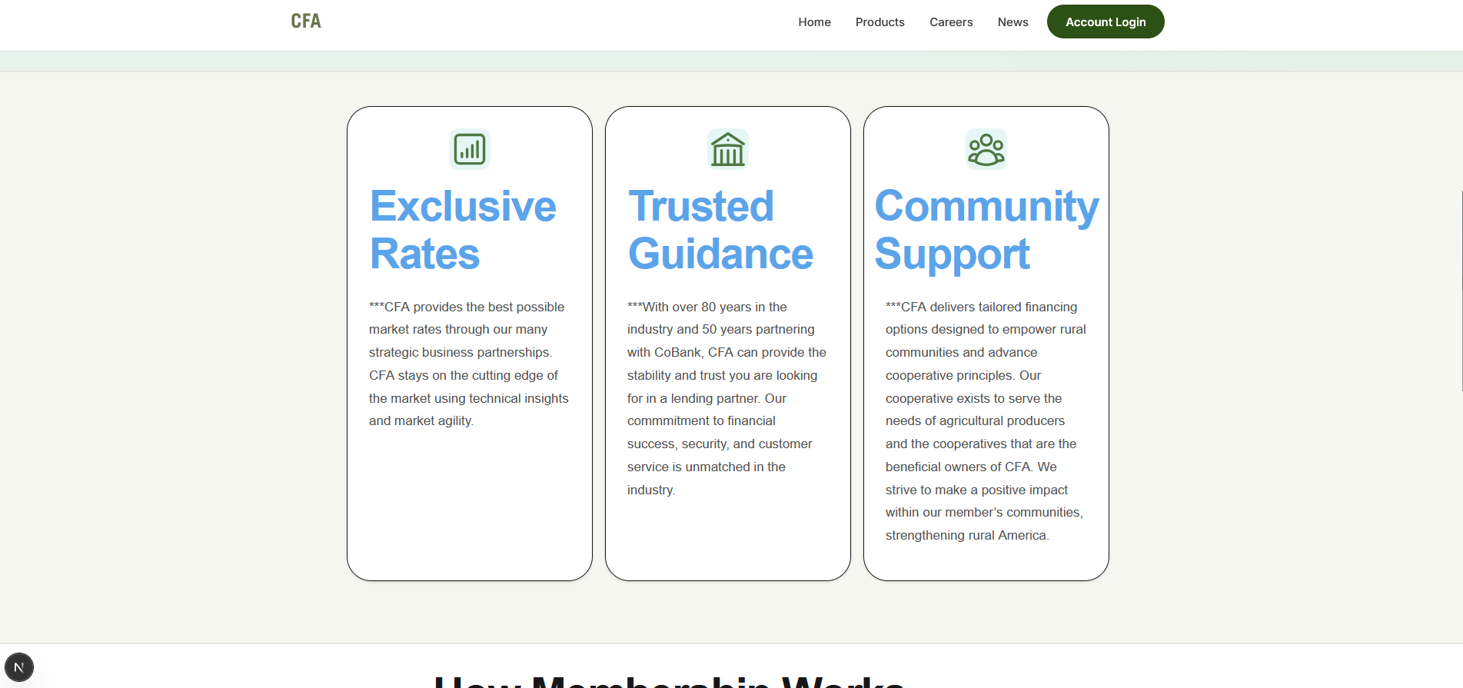
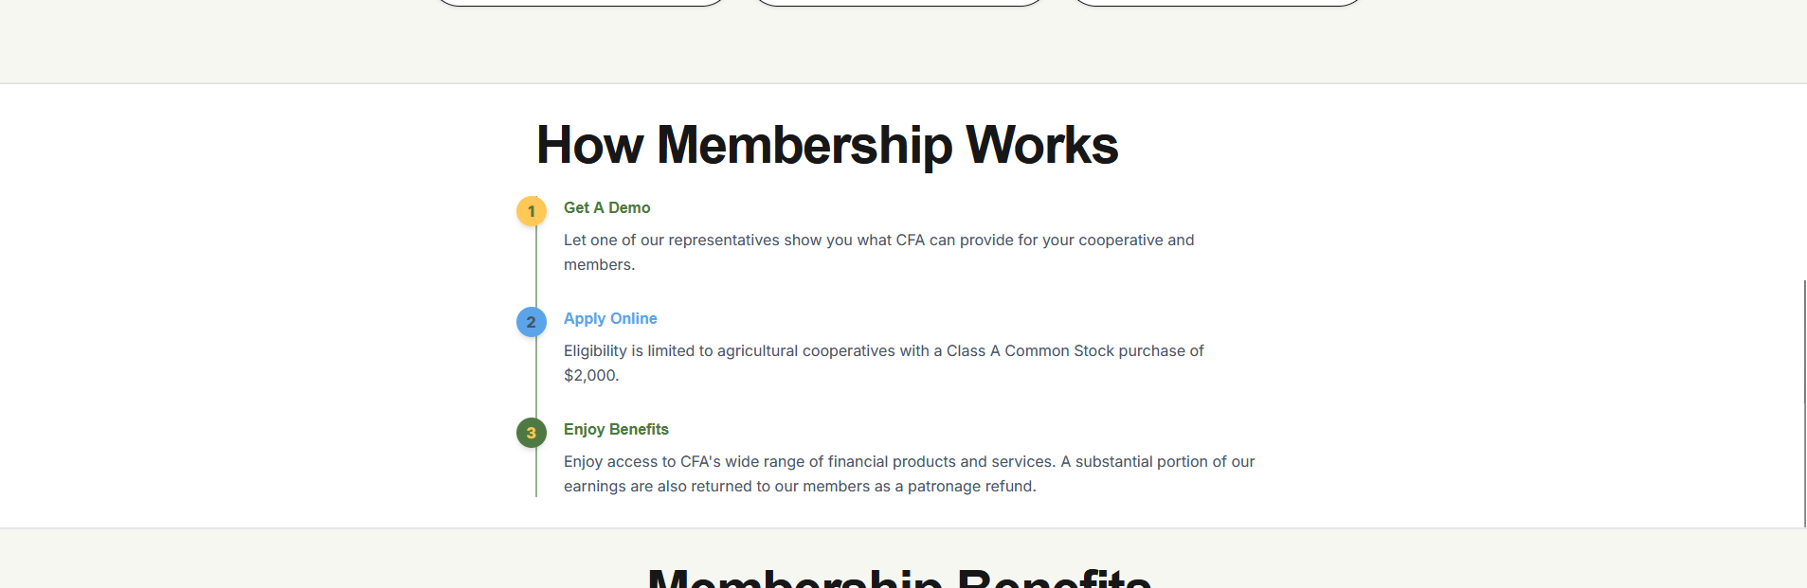
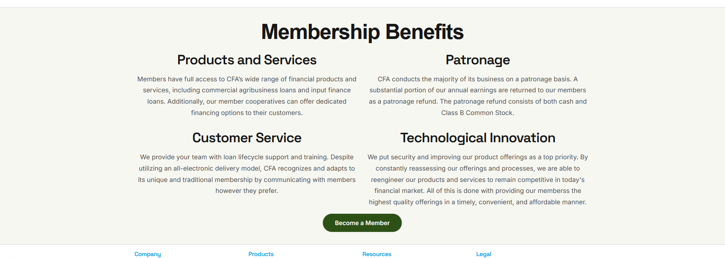

Loan Products: (Not sure how accurate the specifics are on this page)
CFA offers a comprehensive array of financial products and services that are carefully engineered to fulfill customer needs and satisfy the overall demands of the marketplace. In this regard, particular emphasis is accorded to delivering the types of products and services that exceed expectations and out-perform competitive offerings.
Seasonal Operating Loans:
These commercial loans are revolving lines of credit available to finance the seasonal increases in supply inventory, grain inventory, hedging activities, receivables, and operating expenses. Commercial loans are typically secured and may have either variable or fixed interest rates. Operating loans usually mature within 12 months.
Features: Flexible repayment schedules, competitive interest rates, quick approval process, no prepayment penalties
Equipment Financing:
Equipment Loans may be either revolving or non-revolving, are typically secured with assets of the cooperative, and may have either variable or fixed interest rates. The repayment period will be matched to the useful life of the assets financed and to the cash flow to be generated
Features: Up to 7-year Terms, Fixed and Variable Rates, New and Used equipment, 90% financing available
Working Capital Lines:
These loans are single-purpose loans to member cooperatives that have a borrowing relationship with another lender. The loans are used to provide deferred terms and fund 100% of inventory purchases.
Features: Member cooperative selects the invoices to be financed, CFA makes the payments to the suppliers, The loan is due in full once a year, Member cooperative chooses which month of the year you prefer to pay off the loan
Commercial Real Estate:
Term Loans may be either revolving or non-revolving, are typically secured with assets of the cooperative, and may have either variable or fixed interest rates. The repayment period will be matched to the useful life of the assets financed and to the cash flow to be generated.
Features: Flexible Terms, Competitive LTV ratios, construction financing, refinancing options
Competitive Interest Rates:
CFA offers a comprehensive array of financial products and services that are carefully engineered to fulfill customer needs and satisfy the overall demands of the marketplace. In this regard, particular emphasis is accorded to delivering the types of products and services that exceed expectations and out-perform competitive offerings.

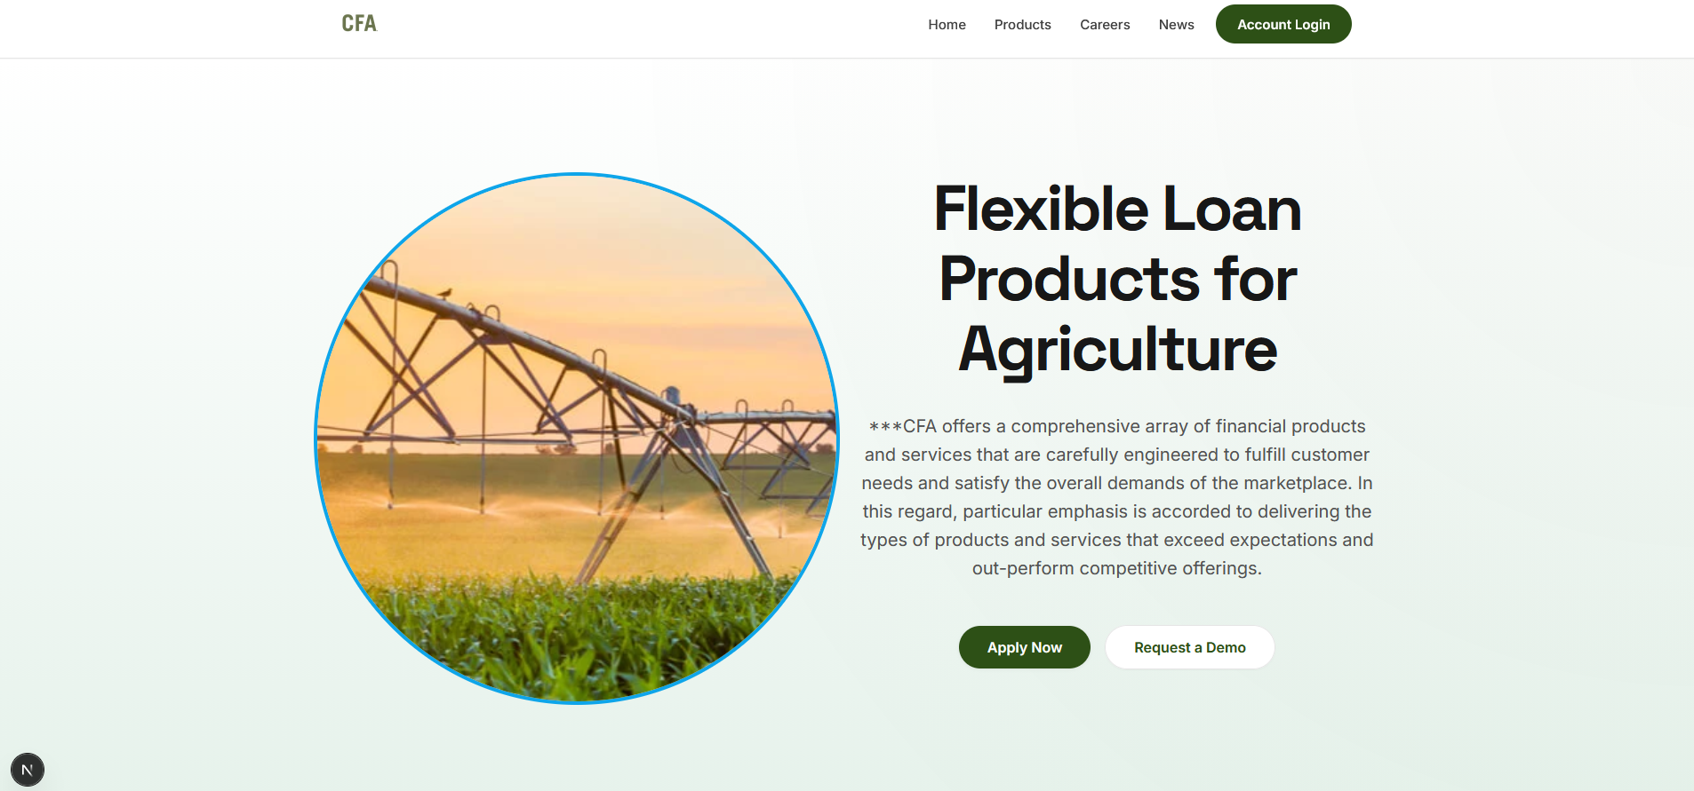
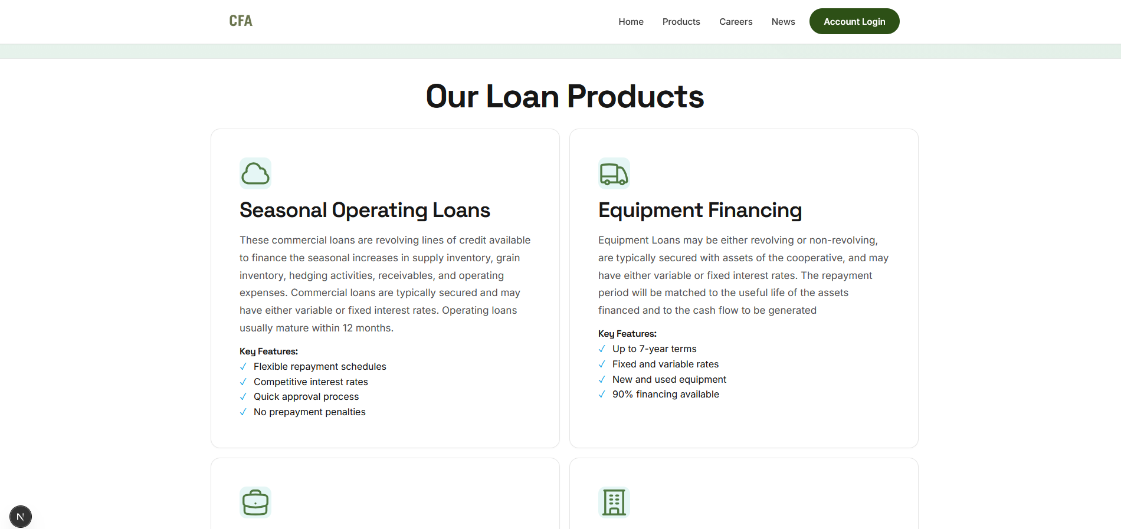
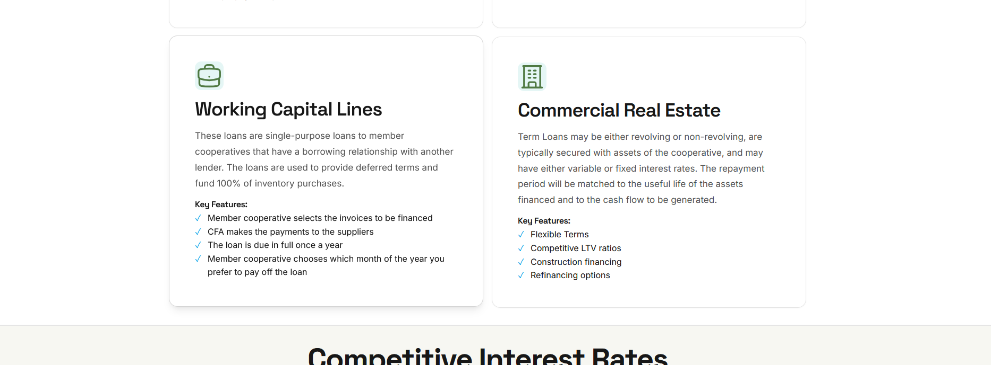
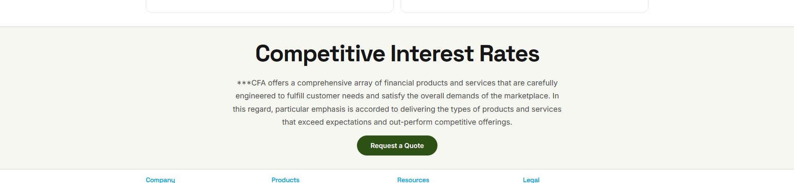

Field Finance:
CFA's cutting-edge loan origination platform, has been a game-changer for agricultural retailers and producers. By streamlining the financing process and offering unparalleled flexibility, Field Finance empowers users to access tailored solutions that align with their operational needs. Request a demo today to learn more about our input financing products.
Request a demo:
Have our expert team give you a tour of our solutions. We have flexible options that can meet the needs of any agricultural portfolio. See how we can improve your input financing options.
Features and Benefits
Convenient - Easy to apply. Fast approval process. Simple loan documentation.
Expert Support - CFA provides ongoing marketing support and training to your staff.
Comprehensive - Finance all agricultural production needs under one loan with CFA.
Cost-Effective - All of the advantages of a captive financing company without the cost of operation or capitalization.
Competitive Advantage - Make your offering very desirable to the customer with easily customizable loan programs and interest subsidy matching.
Flexible - Competitive interest rate options and loan maturities to match your marketing needs.
